Mmanze Centre for Rural Development and Training

[ COMMUNITY EMPOWERMENT INITIATIVE TOWARDS EDUCATION, FOOD SECURITY AND SUSTAINABLE INCOME GENERATION IN MMANZE]
Contact: mulindwak@yahoo.com

MMANZE CENTRE FOR RURAL DEVELOPMENT AND TRAINING
INTRODUCTION
The Mmanze Centre for Rural Development and Training is a community based non government organisation that has been working with rural communities in Uganda to implement community based programs for the last twenty five years.. We work with parents, community members and local leaders.
MACERUDET (Mmanze Centre for Rural Development and Training) is a Ugandan NGO. The organisation is involved in healthcare control and disease prevention programmes, work on AIDS prevention and mitigation, infrastructure and facilities development, skills training and the promotion of women’s rights. MACERUDET is also involved in environmental conservation and a micro-credit programme.
OUR EXPERTISE
We construct rain water harvesting tanks, protected wells and improved pit latrines in schools, health centres and communities

WHERE WE WORK



Mmanze Centre for Rural Development and Training – Macerudet
Mission
To work with the rural communities to improve their standards and conditions of living through implementing sustainable community based programs.
Company Overview
A community-based NGO working with the rural community of Mmanze in Uganda, which was devastated by the Bush War of 1981-1986. Among the complex issues addressed: access to safe water, sanitation, healthcare & education; HIV/AIDS; livelihood means; women's rights.
General Information
The Mmanze Centre takes its name from the Mmanze community, which is found in the Masulita sub-county of Wakiso district (north-west of Kampala).
Its main activities (in no particular order) are:
1. Healthcare - preventative and curative
2. HIV/AIDS prevention, control and mitigation
3. Development of infrastructure and community facilities (including water and sanitation access)
4. Cultural promotion
5. Education
6. Adult literacy
7. Protecting and promoting the rights of the vulnerable, particularly women, children and young people
8. Sustainable agriculture
9. Environmental protection and promoting awareness of environmentally-sound technology
10. Micro-credit creation and management
11. Community capacity-building in all these areas

Background
The African EFA development index compiled by UNESCO places Uganda in 10th position out of 28 countries in its 2012 report. Uganda’s adult and youth literacy rates are above regional averages, however, many children still do not complete primary school and the system has high primary dropout and repetition, which harms primary school completion.
Furthermore, only 37% of children make it to lower secondary and only 12% of school-aged children complete the full secondary cycle. The number of university students has increased to 393 students per 100,000 inhabitants, but still remains below regional standards.
The Importance of Nutrition on Education:
A recent report by the UN's World Food Programme (WFP) concludes that poor nutrition in children can result in stunted growth, and students who were stunted before the age of five are more likely to underperform in school.
As a result, an estimated 133,000 stunted Ugandan children have to repeat academic years because they fail their exams. This generates a cost in school uniforms and exercise books (for parents) and a cost in extra teachers and classrooms (for the government). The total annual bill is estimated to be $9.5m USD.
Operational Capacity:
MACERUDET has more than 25 years of experience in the field of welfare works. The organization already successfully served out the creation of the Busaawa-Mmanze Health Centre III, the Holy Cross Namutenga Community Orphanage Primary School and the Mmanze Community Secondary School. In 2005 the NGO managed a tree re-planting project to oppose the harming practice of burning charcoal and get firewood for selling scopes. MACERUDET also conducted campaigns to inform the community on the HIV/AIDS diseases and prevent children diseases like tetanus, whooping cough, measles and polio developing awareness on vaccination practices among parents.
Project Aim
The projects primary aim is to construct low cost greenhouses within the grounds of 10 schools so that local communities can generate a reliable source of nutrition, as well as income to fund the education of children within the schools catchment area.
Money generated from the greenhouses will be used to fund education across four levels of learning:
- Primary level which costs $ 300 USD per year for a child
- Secondary Ordinary which costs $500 USD per year for a child
- Secondary Advanced which costs $700 USD per year for a child
- University level (or tertiary), which costs $2,000 USD per year for a student

Any surplus cash will be used to buy consumables needed by the community.

The secondary aim of the project is to use the greenhouses to cultivate the growth of banana tissue plantlets. The plantlets can be sold on to local farmers and will provide a premium source of revenue for the community, as the banana is a staple food. The plantlets will also be used to help stabilise the cost and supply of bananas in the region – which can fluctuate significantly – thereby reducing food insecurity.
Rational of the Project
The project has been created to help fund education of 200 socially and economically needy children/orphans per year in the Mmanze community, which is part of the Masulita sub-county and 20 miles (32km) from the Ugandan capital of Kampala.

Each school has approximately 5 acres (20,200m2) of land and 1 acre (4,046m2) of land per school is to be set aside for the greenhouses and their associated facilities.

The aim of the greenhouses is to reliably produce fruits and vegetables, which can be sold-on to fund the education of local children and purchase much needed resources for the Mmanze community. The standard types of crop to be grown include:
• Cabbages
• Tomatoes
• Melons
• Egg plant
• Lettuce

These crops can typically be grown twice a year. The choice of crop will be determined by the season and local demand.

Even with local supply, crop prices in the village market fluctuate greatly based on availability and demand, creating significant food instability. Tomato prices for example can vary over 300% in just 2 weeks. To combat this, the project also proposes the installation of a central cool house where crops can be stored and consumed or sold as needed. The cool house will be solar powered to reduce running costs. A small vehicle with an in-built cooling system is also proposed so that crops transported to local market or the capital, Kampala remain in good condition and obtain the best sale price.

In addition to these standard crops one central greenhouse will be used to grow Banana tissue plantlets.

In most urban areas – such as the capital city Kampala, the populations’ staple food is banana (matooke). Over the last two decades, banana production in Eastern Africa has been on the decline due to the poor availability of clean planting materials, diseases and pests, lack of appropriate technology, poor orchard management and high post-harvest losses. As a result the matooke increasingly comes from the south west of Uganda and is transported more than 300 miles (483km) up to Kampala and the surrounding communities. This has created a negative impact on the price of bananas. Five years ago the cost of a banana bunch in the Mmanze community was less than 5,000 Ugandan Shillings (UGX), today it is more the 10,000 UGX.

A solution to improving the yield of locally grown bananas (and therefore the fruits affordability) is to cultivate the growth of banana tissue seedlings. Tissue culture technology has the advantage of producing large numbers of clean planting material that have fast and uniform growth and produce very high yields. When grown correctly, banana tissue seedlings are proven to yield crops that bear bunches with a success rate of 96%-98% and are more resistant to pests and changing environmental conditions.

A major objective of this project is to reduce the cost of bananas and increase their supply by growing high quality, high yield banana tissue plantlets locally using a central greenhouse. The banana tissue plantlets can then be sold to local farmers, who in turn can grow higher yield bananas to supply Kampala and the surrounding region. As the distance to Kampala is only 20 miles, this significantly reduces transportation costs making the matooke more affordable.
Project Objectives
By building 10 Green houses located in school grounds the project aims to achieve four key objectives within the Mmanze community:
1. A combined, sustainable income of $60,000 USD per year to fund the education of local children resulting in;
2. The further education of up to 1,025 children over the next 5 years.
3. The creation of a locally produced banana tissue plantlet industry resulting in;
4. The increased availability and reduced cost of bananas in the Mmanze community to around 5,000 UGX.

The proposal aims to raise $110,000 USD (284,900,000 UGX) to fund the project designed to meet these objectives.
Planning and Implementation

To implement the project MACERUDET has chosen to work with Bolton CP, a company headquartered in the United Kingdom and with offices in Kampala. Bolton has extensive experience of agricultural development within east Africa and has developed the Amiran farmers Kit (AFK), which provides a greenhouse an all of the associated materials and expertise required to develop, sustainable crop production managed by members within the local community.

The greenhouses also provide drip-irrigation to crops. Drip irrigation significantly increases the yield of vegetables grown. Depending on the crop, yield increases are from 167% to 540% over conventional farming practices.
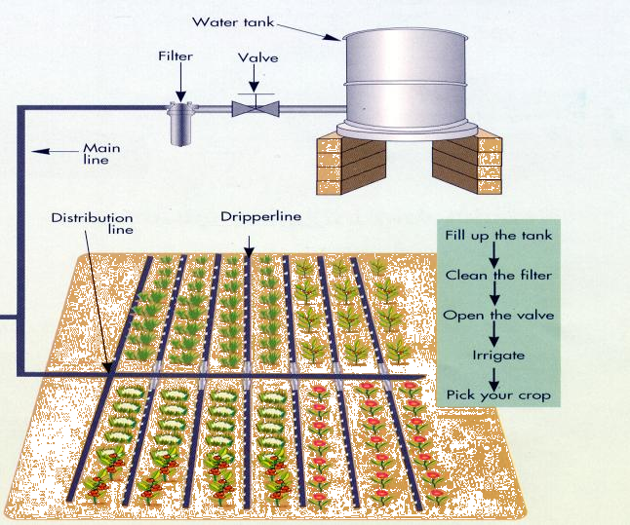
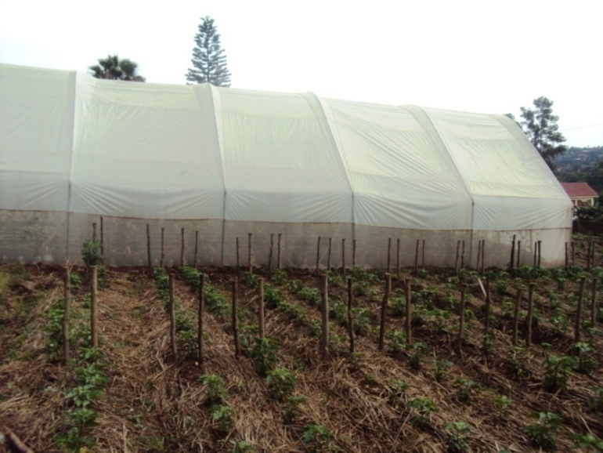
It is recommended that each acre of land comprises one 192m² greenhouse, with the remaining area used for open-air dip irrigated crops.
Example of AFK Greenhouse
Diagram of Drip Irrigation System
An initial pilot site will be used to establish a banana nursery by growing banana trees using the tissue plantlets cultivated in the greenhouse. The greenhouse will be built to facilitate the cultivation of banana tissue as follows:
- Banana tissue plantlets are purchased from Bolton CP.
- The plantlets are weaned for 1 to 2 weeks in a shaded humidity chamber inside the greenhouse, which helps them adapt to the external environment.
- The plantlets are the transferred into a shade-house for around 1 month to harden. After this time the tissue culture banana plantlets are ready to be planted in the grounds next to the greenhouse.

To ensure high yields it is recommended that the plantlets are planted at 3-meter intervals. A total of 350 banana trees can therefore be grown on the 1 acre site once space is set aside for the greenhouse.

To provide revenue flexibility the remaining 9 sites will be used to grow standard crops. However, depending on the success of the pilot site (to be evaluated after 18-months), an additional greenhouse on one of the sites may be used to cultivate banana tissue plantlets for market sale.
The full proposal of equipment provided for the ARK by Bolton CP is available as an appendix to this document.
Economics

Growing Banana Tissue Plantlets and Banana Crops:
The pilot greenhouse can initially accommodate 1,000 banana tissue seedlings in its nursery at a cost of $0.70 USD per seedling. The sale price of each cultivated banana tissue plantlet is around $2.00 USD (5,000 UGX).

It takes approximately 6 weeks to produce a hardened banana tissue plantlet from a tissue seedling in the greenhouses’ nursery. Once completed a further 1,000 seedlings can be taken through the hardening process. This process can be repeated 7 times in the first year (allowing additional time for the farmers to learn how best to cultivate the plantlets). A total of 7,000 hardened plantlets can therefore be produced in the first year.

350 of the plantlets will be planted next the grounds next to the greenhouse to produce banana crops. The remaining 6,650 plantlets will be sold at market.

Once grown the banana crops will produce banana bunches, banana leaves and banana suckers (lower yield planting material). All of which can be sold at market. Revenue from the pilot greenhouse for the first years’ initial crops is therefore broken down as follows:

Crop | Quantity | Average price ($USD) | Total for season
Banana tissue plantlets | 6,650 | 2.00 | $13,300.00
Small banana bunch | 84 | 1.70 | $142.80
Medium banana bunch | 171 | 2.70 | $461.70
Large banana bunch | 95 | 3.27 | $310.65
Banana leaves | 795 | 0.02 | $15.90
Banana suckers | 954 | 0.30 | $286.20
Total Revenue USD  Total Revenue UGX |  |  | $14,517.25  37,556,125 UGX

Once the nursery is fully operational and the farmers well trained, the pilot greenhouse will be capable of producing 10,000 hardened banana tissue plantlets per year. This will result in an annual income of $20,000 USD, equivalent to 50,000,000 UGX.
Revenue from the pilot project will therefore payback its initial $46,031 USD investment within 3 years.
Growing Standard Crops:
Crops such as tomatoes and lettuce will be grown in the grounds adjacent to the greenhouse. All crops will be drip-irrigated to improve their yield.

The table below outlines the revenue that can be generated by growing the following crops on 1 acre of land over 1 season covering 9 months. These figures, provided by South African Department of Rural and Agricultural Affairs (Kwazulu-Natal), represent an average yield and are conservative. With proper cultivation and the use of the greenhouse, actual yields can be up to 50% higher.

Crop | Yield (Kg) | Revenue (USD) | Revenue (UGX)
Tomatoes | 20,365 | 16,122 | 14,810,400
Melons | 9,182 | 4,796 | 4,004,000
Egg plant | 8,516 | 4,496 | 11,176,800
Lettuce | 10,283 | 6,106 | 12,031,200
Cabbage | 25,708 | 10,180 | 11,520,000

It is proposed that the 9 school sites grow a mixture of the 5 crops to limit any loss of revenue should 1 crop suffer from a period of poor growth or disease. If 20% of land use is used for each crop, then the revenue per school site will be approximately $8,340.00

The combined revenue per season from the 9 school sites is approximately $75,060.00 USD. Revenue from each site will therefore payback the construction investment of $63,000 USD within 1 year.
Harvested crops will be stored in central cool house ready for transport to market, or to be consumed as needed by the local community.
Running the Greenhouses:
Each greenhouse can be run as a ‘family unit’. Whilst much of the initial land clearing and ground preparation will be completed by Bolton CP as part of the AFK setup the family unit will need to manage the crops. This will include manure application, weeding and pruning, watering/irrigation and pesticide application.

Once ready, harvesting will occur for around 3 hours, 3 times per week. Each worker in the unit will be paid according to the number of hours worked, where each hour is calculated according to kilograms of crop harvested. The duration of harvesting is typically 9 months with the cost of salaries totalling $397 USD, or 1,022,000 UGX.
Overall Revenue:
The following table provides a breakdown of costs vs. revenue generated per school, per season.

Costs vs. Revenue | Mix of standard crops | Banana tissue nursery and banana crops
Costs
Renewal of planting tools and equipment | $200 | $200
Fertilizers & Agro chemicals | $500 | $500
Salaries for crop maintenance & harvesting | $397 | $397
Seedlings for crops | $200 | $4,900
Maintenance of cool house | $200 | $200
Maintenance and fuel for small vehicle with cooling | $200 | $200
Cost of management and sales to market | $200 | $200
Revenue
Sales per school site | $14,517 | $14,517
PROFIT  (Revenue – Costs) | $6,443 | $7,920

When fully operational the gross profit across all 10 sites will total $65,907.00 per season.
Methodology:
Some $62,000 USD of the annual income generated by the project will go to the education of 205 local children/students per year in the Mmanze community, with remaining income spent on goods and services for locals.
A Project Management Committee selects children through a points system. Parents or guardians must fill in an application form and submit it to the committee for consideration. A child must meet 70% of the selection criteria points to be considered for education support. For example, a double orphan receives 30 points, a single orphan receives 20 points and a child from a single mother family receives 15 points.
The project aims to fund education across four levels of learning:
- Primary level which costs $ 300 USD per year for a child
- Secondary Ordinary which costs $500 USD per year for a child
- Secondary Advanced which costs $700 USD per year for a child
- University level (or tertiary), which costs $2,000 USD per year for a student

The Project Management Committee determines the allocation of funds across the 4 education levels. The average goal of supported education per year as follows:

- 70 Primary level children: Cost $21,000 USD
- 40 Secondary Ordinary level students: Cost $20,000 USD
- 16Secondary Advanced level students: Cost $10,000 USD
- 5 University level students: Cost $10,000 USD

It should be noted that the project will fund child/student tuition fees ,meals at school,scholastic materials,uniform and medical care.However,parents will also have to cater for any other additional costs that may be necessary for the students education .
Release of Funds
$46,031 USD will be drawn down at the beginning of the project to enable to completion of phase 1. The remaining $63,000 USD will be drawn down upon commencement of phase 2.
Execution and Duration of the Project
The project run for 24-months and will be split in to two phases to minimize risk and maximize the return on investment. Each phase will pay for itself within 12-months of completion.
Phase 1: Pilot
The central greenhouse will be built and managed as a nursery to grow banana tissue plantlets for 12 months to ensure that any lessons learnt are applied to the building of the remaining 9 greenhouses. The central greenhouse will be constructed at the Holy Cross Namutenga Community Orphanage Primary School in Mmanze. The remaining acre around the greenhouse will be used to grow banana crops from the tissue plantlets. Growing full-term banana crops will enable the farmers to examine and test the performance of their banana tissue plantlets. Both the bananas and the tissue plantlets can then be sold on to the market.
Bolton CP in Uganda will construct a 192m² greenhouse using the Amiran farmers Kit (AFK) together with the Family drip system (FDS). The construction will take approximately 3 weeks to complete.
Phase 1will also contract an expert in banana tissue cultivation for 1 year to help establish the industry and pass on the skills to local farmers who will then carry on the project. The expert will be also be sourced from Bolton CP as they have experience in this area.
Key milestones in the project are as follows
- Plan layout of greenhouse on 1 acre of land in the selected school
- Begin build of greenhouse and associated facilities
- Train members of the local community on how to manage the greenhouse, cultivate the tissue seedlings and grow the banana crops
- Begin planting of banana crops
- Begin on-going process of cultivation and harvesting.

Phase 2: Rollout
After the first year work will begin on building greenhouses identical to that constructed in Phase 1 across 9 other sites. Locals farmers trained during phase 1 will be used to pass on their skills under the supervision of an agricultural expert provided by Bolton CP.
It is suggested that the 10 schools form a co-operative to sell on their produce as this will increase selling power and help create price stability. Each school should join the co-operative once construction of their greenhouse is completed and the first harvest has been collected. A gradual integration of schools into the co-operative will also better allow for a gradual adjustment of produce to the local market.

