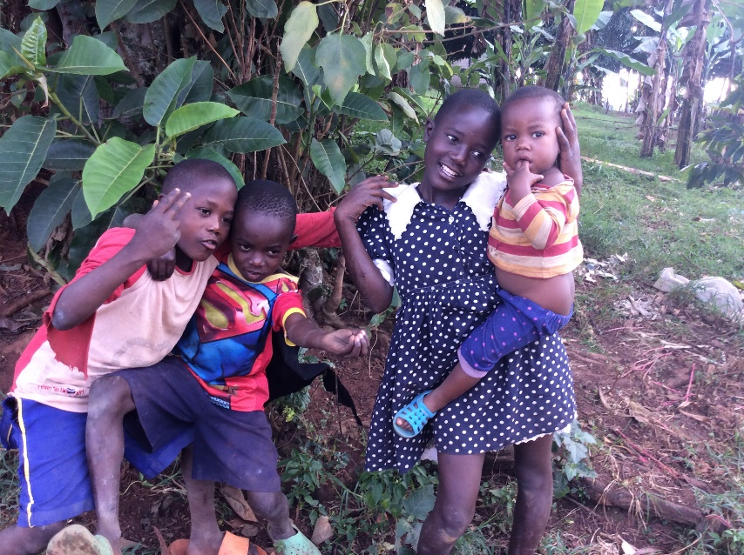
MMANZE FISH FARMING
PROJECT

LOCATION OF PROJECT: Masulita sub county Wakiso district (Uganda)

IMPLEMENTING AGENT: MMANZE CENTRE FOR RURAL DEVELOPMENT AND TRAINING-MACERUDET UGANDA
WEBSITE-https://macerudetuganda.wixsite.com/macerudet
PROJECT COST: 107,998,800Ug.Shs ($30,000)

DONOR SUPPORT: 81,698,800Ug.Shs $23,694)

MFFP/LOCAL CONTRIBUTION: 23,300,000Ug.Shs ($7306)

PROJECT DURATION: 1 YEAR

SUBMISSION DATE: JANUARY 2021

CONTACT PERSON: MR. MULINDWA WILLIAM
DIRECTOR/ CORDINATOR

TEL: +256752827931/+256708317921
Email: mulindwak@yahoo.com

Question: Can aquaculture make good the growing shortfall between the declining yield of capture fisheries and growing consumer demand for fish in Africa?
The answer is yes. The potential is there, as numerous pilot projects have demonstrated and this one will demonstrate and work for communities in
Masuliita subcounty in Wakiso district Central uganda

Background

1.0. History and location
MMANZE FISH FARMING PROJECT is found in Mmanze community,MASULITA Sub County,WAKISO District.The area is located 22 miles along Kampala Matugga Ssemuto.The idea of constructing the fish pondshas been conceived with an aim to supply the community with fish, fight poverty; ignorance and fight diseases by improving local people’s health, lack of funds hindered its goals and objectives. The recent demand for fish in the area has motivated the project to be established as evidenced with the high demand of “Mugongo Wazi” ( BANTUlocal language)remains of fish from the fish factory. The theme of this project is that Money in every one’s pocket. And priority issue is Unemployment and lack of basic services for the youth and the whole community in Masulita subcounty in CentralUganda.

1.1. Project summary
MMANZE FISH FARMING PROJECT- (MFFP) is an innovative proposed project with an aim of mobilizing, organizing and serving small-holder fish farmers in Wakiso district located in central Uganda. MFFP has designed a community-based sustainability project that will provide the tools and resources needed by youth, women, and other interested local people to fight poverty and improve on the livelihood and health, to feed themselves, their families, and their communities. This Fish farming project is also aimed at improving the nutrition of the local people and the neighboring communities by providing cheap source of fish protein, and by putting to ultimate self sustaining use of the available potential places of small scale fish farming in Masulita subcounty in Wakiso District. The project is expected to start with two fish ponds with one MAIN WATER RESOVOIR.

2.0. Organizational overview

2.1. Vision
The vision of Mmanze Fish Farming Project is for every family to have adequate means of livelihood and every individual to experience joy with a productive life.

2.2. Mission
The mission of Mmanze Fish Farming Project is to promote growth to maturity in the physical/ health, socio-emotional, economic/ educational aspects of the communities such that the poor are equipped with life sustaining skills for self reliance

3.0. PROJECT JUSTIFICATION

Fish protein and other fish products are important ingredients in brain development and provision of important animal proteins. Fish is the only cheapest source of animal protein free from cholesterol and calcification. The scarcity of fish has reached an alarming level, when you visit the fish market, people are just lamenting when the refrigerated skeletal fish bones “Mugongo Wazi” is not supplied when they expect it, and how they scramble for it when it arrives is testimony enough of the need and demand for fish. The presence of abundant running water in streams in Mmanze swamp and already existing ponds are resources with big potential to produce fish which can supply the most parts of Masulita sub-county and parts of Wakiso district. There is plenty of manual labor (unemployed youth) which will be used in excavation and masonry work to build extra fish ponds and there is easy means of transport to the market.

3.1. FISH FARMING POTENTIAL
Uganda has a surface area of 241,038km² of which 18.3% are permanent wetlands and 9.4% are seasonal wetlands. These offer enormous potential for fisheries and aquaculture development, this could contribute to a potential of 45% of GDP, creating 80% employment opportunities.

The National economy grew at an average of 6.5% per annum, the fisheries sector growth is about 3% but with a potential to raise to 7%.

The fisheries sector in Uganda provides a vital source of food, providing about 50% of animal protein. It has a current per capita consumption of 11kg. It is also a source of employment, the sector employs close to 80,000 people who are directly involved in catching fish, and a further 800,000 people who are involved in down stream activities related to fishing. It is also a form of recreation; trade with over US $ 80 millions earned per annum from fish exports making the sector second to coffee as foreign exchange earner and socio economic well being for the people of Uganda and the global community.

The total fish production has leveled at 220,000 tones, worth shillings 110 billions at production centre of open waters and aquaculture (ponds and dams). The main open water bodies include Lake Victoria, Albert, Kyoga, Edward, George and Kazinga Channel, Lake Wamala plus about 165 minor lakes. The main rivers are Victoria Nile, Albert Nile and Aswa. There are about 3,000 fish ponds averaging 200m² operating in the whole country. Most of these are in Central and Western parts of Uganda and aimed at production for export.

There are over 300 endemic fish species in Uganda, but the commercially exploited species are Lates niloticus (Nile perch), Alestes Clarias, Barbus hydrocynus, Rastrioneobola and Barbus haplochromis.
A total of 20 fish processing plants were licensed to operate, 9 are operating fully the rest have failed to take off due to insufficient fish supply, competition and government restriction against over fishing due to scarce fishery resources. In the resent years the ministry of agriculture is planning to close a number of fishing sites as a result of the over fishing in Lake Victoria which has resulted into reduction, low catch fish. This project aims at providing and increasing on the production of fish in Uganda.

MFFP will mainly do the following:- ➢ Establish more two fish ponds
- Harvesting of fish for sale, marketing.
- Provide fish farming knowledge to other interested local farmers. ➢ Finding Market for fish produced by local farmers
- Establish proper fish harvesting and management measures.
- To encourage unemployed youth in the community to engage them selves in fish farming

3.2. Needs to be addressed

Rural unemployed women and youth in Wakiso district face a triple crisis of poverty, environmental degradation. Many are struggling to provide enough food to keep their families from starving. Mothers often go hungry when their husbands fail to return with food at home, to ensure that their children can eat many women and youth engage in rice farming in near by wet lands. This is likely to result in the food gap (time taken for rice to mature and harvest). Despite this their energy sacrifice, they end up with little to feed their children and sale to by other needs. Thus resulting into the problem of malnutrition, when it rains during rainy season men always run to wet lands to hunt for fish (see below).therefore providing little fund for this kind of project can be seen as a solution for most family problems.

a 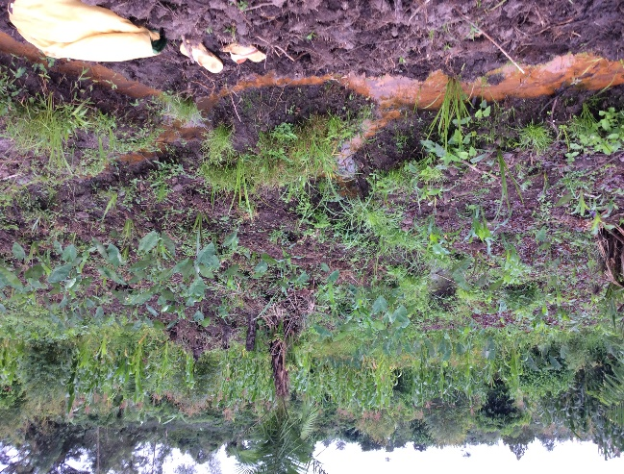 | 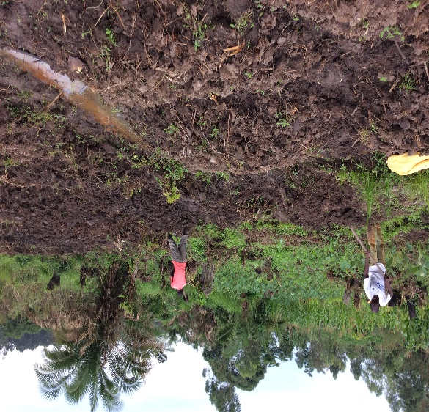  B

4.0. PROJECT OBJECTIVES AND GOALS
The overall objectives are to conserve the environment in Mmanze wetlands; demonstrate the feasibility of fish faming; and encourage small scale fish farmers with a long term goal to overcome fresh fish scarcity and overcome poverty in Eastern parts of Uganda. And to provide an avenue for the local people (unemployed youths, women,) to support their own living in having access to basic services, and be selfreliant through earning their own income through the sales of their fish.

4.1. The specific objectives of the project:
- Provide employment to people of Mmanze community,Maulita sub county-Wakiso District.
- Increase income and standard of living in the community.
- Show that unemployed and uneducated youths are not a problem to the
Community of Mmanze but assets to the community
- Mobilize youths, the local people to work together for common benefits
There are two major goals for Mmanze Fish Farming project.
- To improve the diet of the local community around Masulita Sub County especially those who can not afford to buy meat, milk.
- To effectively use fish pond farming as a method of conserving the wetlands

Clientele
There is one different clientele group for this project.
- The first clientele groups are the local people in the community who will participate in the Project as consumers and as workers. This clientele group is represented in the project objectives for Goal 1
- This clientele group is important and essential component of this project. It is expected that significant attitude change will take place in this clientele group

5.0. METHODS
The primary methods for achieving the goals and objectives of the Project will be:
- The Mmanze pond fish farming in Masulita Sub County that will become a focal point for providing information on fish diet ,and one-on-one counseling of local fish farmers, and group counseling of local fish farmers.
- The development of training program supervised with experienced personnel’s in fish farming sector from the district head quarters.
- In addition, a Documentation/Dissemination Plan will be developed by staff to guarantee the systematic collection of information about the operation of the Project and provide the basis for sharing information with other similar projects in Masulita district

5.0. EVALUATION PLAN
Project evaluation will be the responsibility of the Project Evaluator and consist of two different evaluative strategies - formative and summative.
1.Formative Evaluation - Primarily qualitative in nature, the formative evaluation will be conducted through interviews and open-ended questionnaires local community and the involved fish farmers in community and District will be asked about the day-to-day operation of the project, and questions will be asked to provide feedback for the ongoing improvement of the operation of the Project. The Project Evaluator will meet regularly with project staff to share findings from the formative evaluation effort. Periodic reports will be prepared that identify the major findings of the formative evaluation and how they have been used to improve Project operation.
2. Summative Evaluation - Primarily quantitative in nature, the summative evaluation will begin with the establishment of baseline data at the beginning of the Project (using a random sample of fish farmers to assess their improvement in fish farming knowledge) and then be conducted at 6 month intervals.
A yearly report will be issued that presents the formative and summative findings

5.1. Activities
- Mobilize local community, experts and do awareness of the project
- Purchasing of the fish fingerlings (baby fish) and fish feed to make the two fish pond operative.
- Planning and designing of other fish ponds in the area
- Purchasing of the materials for constructing the other fish pond
- Inspection and certification by Provincial Fisheries experts
- Construction of the whole project components
- Monitoring of the pond water quality and final inspections by experts
- Transferring fingerlings into ponds, feeding and monitoring carefully
- Negotiating for possible buyers or markets
- Transferring of fish into sizes to different ponds
- Start making sales to different buyers
- Creating a bank account and keep the income to make the project a sustainable project by starting again and expanding the size of the project.
- Evaluating of the whole project and provide report to the funder.

5.2. Action needed
- Discuss with community leaders, fisheries authorities in the district, possible markets or buyers, youths, local people and organizations involved to get written commitments to part take in where ever areas they will support.

- Also we really need the funding to plan, prepare and implement the projects as Planned so that its within the timeframe planned

6.0. Out Comes and Beneficiaries

6.1. Outcomes
Expected results of the Mmanze Fish Farming Project (MFFP) are:
- Improve diets of Mmanze fish farmers and their families as they gain access to higher-quality and more regular sources of nutrition;
- Introduce youth, women and rural fish farmers who have not previously had access to credit or participated in income-generating projects to the commercial sector and the market; give youth, women and rural fish farmers experience with credit, profit, and savings; and help them move toward economic self-sufficiency; and Increase status of these farmers in their homes and communities and, as they take on responsibility outside the home, enable them to negotiate distribution of work in the household with family members and provide positive role models for their children, both in terms of hard work and innovations.

6.2. Beneficiaries

MFFP project will include both youth, women, interested fish farmers and will benefit these individuals and their family members, more than 1000 people. Some of the participants in the project will include fish farmers, sellers, buyers, and workers. Many participants targeted have lived in Mmanze for a number of years, but have had limited access to agricultural support, and other government farm aid programs. Some of them may have been left out as a result of lack of land to carry out farming. Due to financial and social constraints, many of the youth, women have not had access to joining vocational institutions and have little means of generating income for their families. Thus this project may pave way to solve these financial and social constraints.

7.0. PROJECT MANAGEMENT
- The project will be managed by the Project Coordinator, who will work hand in hand with the project committee comprising of employers, district fisheries technical support office, and a member from the donor organization who will ensure timely and quality project implementation and accountability.
- The implementing committee will comprise of the Project Coordinator and the project committee who will hire and supervise the employers on feeding and the overall stocking and management of the project.
- The Project Coordinator is the a Social and Director of the MACERUDET organisation, who will keep all the records of transactions, with evidence of genuine receipts, bank statements of all the transactions. Will submit progressive and completion reports with full accountability to Donors and District Authorities who will be concerned about the project.
- The district and national fisheries and Environment offices will provide the needed technical support and supervision during the implementation stage.
- The monitoring and evaluation will be carried out by the Project Committee and Coordinator who will be answerable to the board of directors, donors. This will be done through periodic meetings.

8.0. ENVIRONMENTAL IMPACT
- Fish farming in ponds is environmentally friendly and will not have adverse environmental impact on the ecosystem in the swamp.
- The water will circulate freely in the swamps Plants, flowers and trees will be planted on the pond pavements to regulate the aeration in the ponds.
- There will not be significant garbage from the fish project; any garbage produced will be deposited in gazette areas.
- The project has maintained proper environmental procedures for example as seen in the picture above (one of the fish pond) trees are maintained at the boundaries of the fish pond, grasses are left outside inlet to help in filtering the water entering the pond.

8.0. The physical and social benefits of the project will be:
- Improved health of the communities.
- Provision of fish protein, which will enhance brain development in children and improved brain power in adults.
- Increased creativity and innovativeness among the youth, and local people.
- Provision of fresh fish protecting people from eating fish skeletal bones.
- Provision of employment to the local people.
- The project after seed money from partners will become self sustaining and the generated income will be used as seed funds to help individual farmer members to start their own fish ponds to increase availability of fresh fish in the region.
- Socially the project will benefit the youths by providing employment to both trained and untrained.
- The community will generate money, from the sale of fish, which will enable every family to keep at least two Friesian cows for production of milk. This will also enable parents send their children to school. The families will also be enabled to meet medical expenses.

8.1. PROJECT INDICATORS
- Increased involvement of families in fish farming.
- Increased demand and supply of fish.
- Decreased mortality and morbidity of children.
- Improved standards of living and health in families.
- Improved school performance standards and creativity among the people.
- Increased youth involvement into fish farming.
- Ensured food security
- Eradicated poverty in Mmanze community in Wakiso district

PROPOSED BUDGET FOR THE MMANZE FISH FARMING PROJECT –MFFP
Note: 1USD is budgeted at 3600ugx

DESCRIPTION OF ACTIVITY | QUANTITY | UNIT COST IN UG SHS | TOTAL COST IN UG SHS. | TOTAL COST. USD | FUNDING SOURCE
1. CONSTRUCTION  a. inlet and outlet channels  b. plumbing materials  c. pond digging manual  d. Water Reservoir digging Manuel | 150 meters  5PVCP PIPES  5PVCPT –JOINTS  5PVCP Elbow joint  2 ponds  Size 125ftx50ft  One reservoir 100ftx50ft | 6,000/=  60,000/=  40,000/=  10,000=  5,000,000/=  4,000,000/= | 900,000/=  300,000/=  200,000/=  50,000/=  10,000,000/=  4,000,000/= | 250$  83$  56$  14$  2,778$  1111$ | MFFP  GRANT  GRANT  Grant  MFFP in kind  MFFP in kind
SUB TOTAL |  |  | 15,450,000/= | 4292$ | MFFP/GRANT
2 .ACQUISITION AND STOCKING OF PONDS WITH FISH FINGERLINGS.  a) Cat Fish  Fingerling Seeds.  ) Nile Tilapia  Fingerling Seeds | 20,000 in 2 ponds  10,000 in 2ponds | 500=.  800/- | 10,000,000/=  8,000,000/= | 2778$  2222$ | Grant  Grant
Sub total |  |  | 18,000,000/= | 5,000$ | grant
FENCING  a. wire-net fencing  b. u nails  c. mansion poles  d. labour | 60 nets  galvanized  50kg  120 poles  Lump sum | 100,000/=  10,000/=  50,000/= | 6,000,000/=  500,000/=  6,000,000/=  1,500,000/= | 1667$  139$  1667$  417$ | Grant  Grant  Grant  Grant
Sub total |  |  | 14,000,000/= | 3889$ | Grant
4 FISH FARMING IMPLEMENTATION  a).Fish Feeding  b. security  c. Day To Day Management  d. employees | 100kgx  30daysx8mnths  1 personx12months  Project directorx12months  2peoplex12months | 1000/=  150,000/=  500,000/=  150,000/=@ | 24,000,000/=  1,800,000/=  6,000,000/=  3,600,000/= | 6667$  500$  1667$  1000$ | Grant  MFFP  MFFP
Sub total |  |  | 35,400,000/= | 9834$ | MFFP/GRANT
5.HARVESTING,  HANDLING  AND  MARKETING  a. Marketing motorcycles  b. deep freezer | 2 cycles  1 freezer | 5,000,000/=  7,574,400/= | 10,000,000/=  7,574,400/= | 2778$  2104$ | Grant  Grant
Sub total |  |  | 17,574,400/= | 4882$ | Grant
6. COMMUNITY CAPACITY BUILDING THROUGH TRAINING  Training farmers in fish farming and management | 100peoplex2days |  | 7,574,400/= | 2104$ | Grant
Sub total |  |  | 7,574,400/= | 2104$ | Grant
Grand total |  |  | 107,998,800/= | 30,000$ | MFFP/GRANT
. .

SUMMARY OF BUDGET NEEDING DONOR PARTNERS SUPPORT
DESCRIPTION OF ACTIVITIES NEEDING SUPPORT
NOTE 1 USD is budgeted at Uganda shillings 3,600=

ACTIVITY | AMOUNT  IN UG SHS. | AMOUNT  IN USD
CONSTRUCTION | 15,450,000= | 4292$
ACQUISITION AND STOCKING OF PONDS  WITH FISH FINGERLINGS. | 18,000,000=. | 5,000$
-FENCING. | 14,000,000=. | 3889$
FISH FARMING IMPLEMENTATION | 35,400,000/= | 9838$
HARVESTING,HANDLING AND MARKETING | 17,574,400/= | 4882$
COMMUNITY CAPACITY BUILDING THROUGH  TRAINING FARMERS IN FISH FARMING AND  MANAGEMENT. | 7,574,400/= | 2104$
TOTAL COSTS TO BE SUPPORTED BY DONORS | 81,698,800/= | 23,694$
-TOTAL COSTS TO BE SUPPORTED BY MFFP  IN KIND | 26,300.000/= | 7306$
GRAND TOTAL BUDGET. | 107,998,800/= | 30,000$

THE ECONOMIC FEASIBILITY OF THE PROJECT IS EXPECTED TO BE AS FOLLOWS:
Total Investment in this project is expected to be: 107,998,800=. 30,000$
EXPECTED INCOME FROM FISH SALES:
-African Cat Fish Initial Stock. 20,000 fries
-Nile Tilapia Initial Stock. 10,000 fries
-African Cat Fish Reproduction Rate :40-60%
Therefore, the Initial Stock would reproduce an average of 50%x 20,000=10,000
-At the end of the farming cycle there would be 20,000+10,000= 30,000 African Cat Fish Fries.
At the end of the harvest period of 6-8 months each Cat Fish Fries is expected to mature at 0.7 kg.
-Therefore 30,000 Fries will be expected to produce 30,000x 0.7 kg= 21,000kg
-Nile Tilapia reproduction rate = 60-80%
-Therefore the Initial Stock would reproduce an average of 65% of 10,000= 6,000 Fries
-At the end of the farming cycle there would be 10,000+ 6,000= 16,000 Nile Tilapia Fries.
-At the end of the harvest period of 6-8 months each Nile Tilapia is expected to mature to 0.5 kg
-Therefore The 16,000 Nile Tilapia Fries will produce 0.5x 16,000=8,000kg
Therefore, total output is expected to be 21,000kg from African Cat Fish+ 8,000kg from Nile Tilapia =29,000kg.
1 Kg of fresh fish is expected to cost an average of 5,000= Uganda shillings.
Therefore, the 29,000 kg is expected to generate an income of 29,000x 5,000=145,000,000= Uganda shillings in a period of 6-8 months.
The expected rate of return on investment will therefore be Total Income/Total Investment x100= 145,000,000/107,998,800x 100=134%
Therefore, Net Economic Profit On Investment= 37,001,200=Uganda shillings (10,278$)
Regards,
Mulindwa william
Director

WORK PLAN FOR THE NIKIMU FISH FARMING PROJECT (NFFP)

DATE | ACTIVITIES | BUDGETS | PERSON RESPONSIBLE
Apr-13 | Mobilize local community, experts and do awareness of the project | 100000 | Coordinator
Apr-13 | Planning and designing of other fish ponds | 120000 | Coordinator
Apr-13 | Purchasing of the materials for constructing the ponds | 20 | Coordinator
May -13 | Inspection and certification by Provincial Fisheries experts | 100000 | Coordinator
May -13 | Monitoring of the pond water quality and final inspections by experts | 50000 | Coordinator, committee
May -13 | Purchasing of the fish fingerlings  (baby fish) and fish feed, transferring fingerlings into ponds, feeding. | 250000 | Coordinator, committee
May -13 | Transferring of fish into sizes to different ponds | 0 | Coordinator, committee
June-  0ctober 13 | Feeding |  | Coordinator, committee
November13 | Fish harvesting, , and marketing | 50,000 | Coordinator, committee
December13 | Negotiating for possible buyers or markets | 0 | Coordinator, committee
Jan-13 | Start making sales to different buyers in cities | 0 | Coordinator, committee
Feb&Mar-  13 | Creating a bank account for keeping the income to make the project a sustainable project by starting again and expanding the size of the project. |  | Coordinator, committee
April-10 | Evaluating of the whole project and provide report to the funder | 70000 | Coordinator, committee

CONCLUSION AND APPEAL
- People need fresh fish protein to remain healthy and productive.
- Fish farming is very viable and economically, physically and biologically feasible with great benefits to the community.
- We appreciate the fact that this is a big project with big initial capital; we are requesting you to support the 3 seed fish ponds to cater for the community
- we therefore invite you to be part of this great vision aimed at improving the
Nutrition, economic standards and health of the people

YOUR SUPPORT

MACERUDET has been advancing fish farming and advantages of growing fish demand in communities around the Masulita sub county for the past 24 years. We aim at creating a positive attitude change in the fish farming in the area.
Your support of MFFP and our work in Masulita Sub County is crucial to our ability to meet the immediate and long-term needs of most local farmers and their families. You can be sure that your investment will have an impact. We thank you for your consideration of this important request. May God richly bless you as you support this project.

Table Shows How Pond Fish Farming Contributes To Millennium Development Goals

Millennium development goal | How pond fish farming contribute to MDGs
Eradicate extreme poverty and hunger | Fish protein(proper nutrition) correlates with reduced health care, it is proved that a lot of money is spent on treating many nutritional diseases including protein deficiencies in Uganda for example kwashiorkor ; project will improve food security by constant production and supply of fresh fish in the District and the Surrounding communities. Fish farming in potential sites will provide employment for at least thousands of people in Mmanzecommunity and Wakiso District as a whole, and income to farmers who will get involved in fish farming hence reducing poverty
Achieve Universal Primary Education  Target: Ensure that by 20015, children every where, boys and girls a like, will be able to complete a full course of Primary Schooling millennium summit | Fish protein is very important in brain cells development and therefore the mental and brain capacity of children. The poor academic and creativity capacity of the people is closely associated with lack protein in children’s diet, egg protein will enable boys and girls a like, complete a full course of  Primary without difficulties
Promote gender equality and empower women | Fish farming activities are executed both by men and women, except for pond construction and digging is considered man's work
Reduce child mortality  Target ; reduce by two- thirds, between 1990 and 2015, the under-five mortality rate (millennium summit) | Fish protein fights the most deadly disease  (kwashiorkor)  Caused by lack or low protein content in children Known to claim number of children in developing nations including Uganda.
Improve maternal Health  Target ; Reduce by three-quarters, between 1990  and 2015, the maternal mortality ratio ( millennium summit) | Improved nutrition (through fish protein) can reduce the susceptibility of a woman to diseases which appear during pregnancy. Including women of child –bearing age as "end points" in health assessments of  Nutrition will inform  Public health strategies as geared health of women, their children and the foetus.
Combat HIV/AIDs, malaria and other  Diseases  Target ; Have halted by 2015 and begun to reverse the spread of HIV/AIDS(millennium summit) | Food security and improved nutrition helps in fighting diseases, improved nutrition (through egg protein) can help to boost the immune system of people suffering from HIV/AIDS.
Target: Have halted by 2030 and begun to reverse the incidence of malaria and other Major Diseases (millennium summit)
Ensure environmental sustainability  Target : Integrate the principles of sustainable development in to the country polices and reverse the loss of environmental recourses | By products will be recycled into poultry and animal feeds(organic farming)  , this promotes environmental sustainability, as compared to the use of inorganic fertilizers
Develop a global partnership for development | International (FAO) and other organizations represent a potential international funding to support national capacity building for food security and improve fish farming in Uganda.  Promoting partnership with many fisheries organization and ministries will benefit the development of fisheries sector in Uganda

ADVANTAGES OF FISH FARMING
Consumption. An advantage of fish over other animal products is that chickens, goats and cattle are only consumed on special occasions such as traditional ceremonies, funerals and weddings, whereas fish forms part of the normal diet. This means that if somebody is hungry he/she will not slaughter a chicken, but he/she may go to the pond to catch fish.
Saving function. Farming fish can also have a saving function; the moment a farmer needs money he/she can drain the pond or catch part of the fish and sell it.
Flexible labour demand. Many farmers do not expand their farms because of the heavy workload in the planting and weeding season. In aquaculture, the construction of the pond demands a lot of work but is not restricted to a particular period. It can be done whenever the farmer has some spare time. Once the construction is finished the management of the pond does not require much time. The labour constraint for expanding agricultural activities does not seriously affect aquaculture

APPENDIX A- COMMUNITY DIAGNOSIS

The community diagnosis was taken to find out the demand of local fish and how fish farming can by another enterprise to address nutritional, health and the livelihood of the community. This was done in 50 families of Masulita sub-county.

The diagnosis was conducted between March and April, 2020 using interview, survey walk and direct observation.
In the diagnosis it was found out that community wanted much to use fresh fish in their diet but it was scarce and many community farmers were willing to embrace the activity of fish farming If they saw it practiced profitably in the community and the had information on how the activity is done.

APPENDIX B- DEMOGRAPHICS OF WAKISO DISTRICT

Just like in Uganda Wakiso district has high ethnic groups existing at time but the 2016 population and housing censes analytical report for Wakiso shows that Baganda 82.2% which is the native, followed Basoga8.5% and the least Barundi and Banyara 0.1% .

Population: 2,007,700
Note: The figure an above for this district got from 2016 population and
housing censes analytical report for Wakiso

Age structure
0-14 years: 51.8%
15-64 years: 44.2%
65 years and over: 4%
Population growth rate: 2.94% (2016)
Birth rate: 50.15 births/1,000 population (2016)
Death rate: 6.5 deaths/1,000 population (2016)

Major economic activities;
The 2002 population and housing censes analytical report for Wakiso Shows that 81% working population are distributed in agriculture and fisheries and only 6.3% were office related workers. This can conclude the level of education is generally low in Wakiso

Households
There are 26,655 households in Wakiso District with 17.6 % in Masulita sub-county; there are 8, sub-counties in the District ,town councils nd municipalities.
Religions: Roman Catholic 27.6%, Protestant 43.8%,
Pentecostals1.5%,SeventhDay Adventists 0.8,Muslim 24.8%, indigenous beliefs 1.5%
Languages: Luganda mostly used by the Natives English (official national language, taught in grade schools, used in courts of law and by most newspapers and some radio broadcasts),Swahili, Literacy:
Definition: age 15 and over can read and write
Total population: 60%
Male: 54.5%
Female: 45.5% (2000)
The information from 2016 population and housing censes analytical report for Wakiso

Main source of household livelihood
According to the 2016 census, the major source of livelihood for the household is subsistence farming with 85.5%, Employment income only made up of 5.3 % and the family support was 5%. This shows that there are high levels of poverty and also that employment opportunities in the district are very

